CSE 422 Homework 2

|  |  |  |  |  |  |  |  |  |
| --- | --- | --- | --- | --- | --- | --- | --- | --- |
| STEP | N’ | D(t),p(t) | D(u),p(u) | D(v),p(v) | D(w),p(w) | D(x),p(x) | D(y),p(y) | D(z),p(z) |
| 0 | u | **2, u** | 0, u | 3, u | 3, u | inf | inf | inf |
| 1 | ut | 2, u | 0, u | **3, u** | 3, u | inf | 9, t | inf |
| 2 | utv | 2, u | 0, u | 3, u | **3, u** | 6, v | 9, t | inf |
| 3 | utvw | 2, u | 0, u | 3, u | 3, u | **6, v** | 9, t | inf |
| 4 | utvwx | 2, u | 0, u | 3, u | 3, u | 6, v | **9, t** | 14, x |
| 5 | utvwxy | 2, u | 0, u | 3, u | 3, u | 6, v | 9, t | 14, x |

* 1. Node u
  2. Node w

|  |  |  |  |  |  |  |  |  |
| --- | --- | --- | --- | --- | --- | --- | --- | --- |
| STEP | N’ | D(t),p(t) | D(u),p(u) | D(v),p(v) | D(w),p(w) | D(x),p(x) | D(y),p(y) | D(z),p(z) |
| 0 | w | inf | **3, w** | 4, w | 0, w | 6, w | inf | inf |
| 1 | wu | 5, u | 3, w | **4, w** | 0, w | 6, w | inf | inf |
| 2 | wuv | **5, u** | 3, w | 4, w | 0, w | 6, w | 12, v | inf |
| 3 | wuvt | 5, u | 3, w | 4, w | 0, w | **6, w** | 12, t | inf |
| 4 | wuvtx | 5, u | 3, w | 4, w | 0, w | 6, w | **12, t** | 14, x |
| 5 | wuvtxy | 5, u | 3, w | 4, w | 0, w | 6, w | 12, t | 14, x |

* 1. Hierarchical Routing is needed when operating at large scales for efficiency and it gives administrative autonomy as each network admin may want to control routing within their network.
  2. A network or a collection of networks that are operated by a single entity for easy management.
  3. Routing Information Protocol (RIP), Open Shortest Path First (OSPF).
  4. Border Gateway Protocol (BGP)
  5. The chosen route might not be the shortest AS-path because of costs. If a path is longer but significantly cheaper, there is a possibility that it would be selected over the shorted path.
  6. eBGP
  7. iBGP
  8. eBGP
  9. iBGP
  10. I­1, because this is part of the shortest path from 1d to 1c.
  11. I2, because this is part of the path that has the closest NEXT-HOP router.
  12. 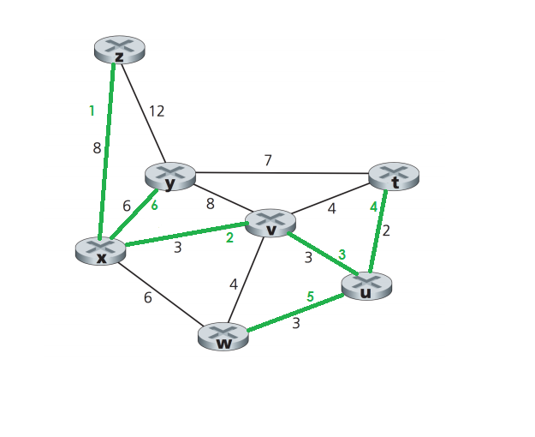I1, because this is part of the path with the shortest AS-PATH.

1. Order of traversal shown in green.
2. –
   1. –
   2. Src IP: Ad2

Dst IP: Ad4

Src MAC: Ad2

Dst MAC: Ad4

* 1. Scr IP: Ad4

Dst IP: F

Scr MAC: Ad4

Dst MAC: F

* 1. -
  2. d0, d1 : 1 x (1, -1, 1, 1, 1, -1, 1, 1) = (1, -1, 1, 1, 1, -1, 1, 1)

|  |  |  |  |  |  |  |  |  |  |  |  |  |  |  |  |  |
| --- | --- | --- | --- | --- | --- | --- | --- | --- | --- | --- | --- | --- | --- | --- | --- | --- |
| 0 | -2 | 0 | 2 | 0 | 0 | 2 | 2 | 2 | | 0 | 2 | 0 | 2 | -2 | 0 |  |
| Time Slot 1 | | | | | | | | | Time Slot 2 | | | | | | | | |
| 1 | -1 | 1 | 1 | 1 | -1 | 1 | 1 | 1 | | -1 | 1 | 1 | 1 | -1 | 1 | 1 |

d1 = [2+2+2+2]/8 = 1 d0 = [2+2+2+2]/8 = 1

* 1. d0 : (1, -1, 1, 1, 1, -1, 1, 1) d1: -1 x (1, -1, 1, 1, 1, -1, 1, 1) = (-1, 1, -1, -1, -1, 1, -1, -1)

|  |  |  |  |  |  |  |  |  |  |  |  |  |  |  |  |
| --- | --- | --- | --- | --- | --- | --- | --- | --- | --- | --- | --- | --- | --- | --- | --- |
| 0 | 2 | 0 | -2 | 0 | 0 | -2 | -2 | 0 | -2 | 0 | 2 | 0 | 0 | 2 | 2 |

* 1. s2 :

|  |  |  |  |  |  |  |  |  |  |  |  |  |  |  |  |  |
| --- | --- | --- | --- | --- | --- | --- | --- | --- | --- | --- | --- | --- | --- | --- | --- | --- |
| 0 | 2 | 0 | -2 | 0 | 0 | -2 | -2 | 0 | | -2 | 0 | 2 | 0 | 0 | 2 | 2 |
| Time Slot 1 | | | | | | | | | Time Slot 2 | | | | | | | | |
| 1 | -1 | 1 | 1 | 1 | -1 | 1 | 1 | 1 | | -1 | 1 | 1 | 1 | -1 | 1 | 1 |

d1 = [-2-2-2-2]/8 = -1 d0 = [2+2+2+2] = 1

* + 1. CSMA: Carrier-sense multiple access
    2. CSMA/CA: Carrier-sense multiple access with collision avoidance
    3. CSMA/CD: Carrier-sense multiple access with collision detection
  1. If the sender senses that the channel is busy, it will defer the transmission. If the channel is not busy, it will transmit the entire frame.
  2. –
  3. Operates the same as pure CSMA however, before transmission, a random timer is started. After the timer, transmission occurs and receiver sends back ACK upon receiving packet.
  4. Operates the same as pure CSMA however, when a collision is detected, the NIC aborts transmission and enters binary back off. After the mth collision, the NIC chooses K at random from {0,1,2…,2m-1}. The NIC then waits for K * 512 bit times then checks if the channel is idle. If multiple collisions are detected, the back off interval is increased.
  5. Wireless transceivers can’t send and receive on the same channel at the same time.
     1. SNR: Signal to noise ratio
     2. BER: Bit error rate
  6. Decrease
  7. Increasing transmission power and reducing the transmission rate.
  8. –
  9. Path loss due to the attenuation of the electromagnetic signal when it travels through matter. Multipath propagation results in the blurring of the received signal at the receiver and occurs when portions of the EM wave reflect of objects and take paths of different lengths. Interference from other source that are transmitting in the same frequency range as the wireless network.
  10. Yes, they are still necessary to avoid the hidden terminal problem. The CTS and RTS frames makes sure a node A sending to B won’t interfere with another node C also attempting to contact B.
  11. -
  12. Each wireless station can set an RTS threshold such that the RTS/CTS sequence is used only when the frame is longer than the threshold. This ensures that RTS/CTS is used only for large enough frames.
      1. Home Agent: Entity that will perform mobility functions on behalf of mobile when mobile is remote.
      2. Foreign Agent: Entity in visited network that performs mobility functions on behalf of mobile.
      3. Correspondent: Wants to communicate with mobile.
  13. It is not scalable to millions of mobile devices.
  14. Permanent address is used by correspondent (hence mobile location is transparent to correspondent). COA is used by home agent to forward datagrams to mobile.
  15. Route call via new base station without interruption.
  16. Stronger signal to/from new base station. Load balance to free up channel on current base station.